1. Name the symbol of Uganda as a Nation that also displays the National Emblem.

…………………………………………………………………………………………………………………………………………………………….......................

1. Mention any other way of respecting the National Anthem when it is being sung apart from standing up.

…………………………………………………………………………………………………………………………………………………………………………………

1. What was the importance of singing the National Anthem on 9th October, 1962?

………………………………………………………………………………………………………………………………………………………………………………….

1. How did the coming of the Bantu affect the people in the areas they settled?

………………………………………………………………………………………………………………………………………………………………………………….

1. Mention any one factor that forced the British to grant Uganda her independence.

………………………………………………………………………………………………………………………………………………………………………………….

1. Give any one reason why Ugandans hated paying taxes that were introduced by the British colonialists.

………………………………………………………………………………………………………………………………………………………………………………....

1. State any one way trade with the coastal Arabs helped in the expansion of Buganda.

………………………………………………………………………………………………………………………………………………………………………………...

1. Why were the Abatembuzi referred to as Semi gods?

…………………………………………………………………………………………………………………………………………………………………………………

1. Mention any one factor that made it difficult for early explorers to Uganda to pass through Kenya.

…………………………………………………………………………………………………………………………………………………………………………………

1. How did Lenant de Bellefonds contribute to the coming of the first missionaries to Uganda?

………………………………………………………………………………………………………………………………………………………………………………….

1. What was the first missionary school to be opened in Uganda?

………………………………………………………………………………………………………………………………………………………………………………….

1. State the reason why Omukama Kabalega drove away Omukama Kasagama of Tooro?

………………………………………………………………………………………………………………………………………………………………………………...

1. Mention any one way Nuwa Mbaguta was helpful to the British colonialists?

…………………………………………………………………………………………………………………………………………………………………………………

1. How did the Eastern Rift valley make the construction of the Uganda Railway so difficult?

………………………………………………………………………………………………………………………………………………………………………………….

1. Name the group of people who were brought to solve the problem of labour during the construction of the Uganda railway.

………………………………………………………………………………………………………………………………………………………………………………….

1. Why was I.K Musaazi regarded as a National hero in Uganda?

………………………………………………………………………………………………………………………………………………………………………………….

1. How did the Uganda People’s Congress (UPC) benefit from the alliance with Kabaka Yekka (KY)?

…………………………………………………………………………………………………………………………………………………………………………………

1. How was Nationalism promoted in Uganda before 1962?

………………………………………………………………………………………………………………………………………………………………………………….

1. What shows that Uganda was once a British Protectorate?

………………………………………………………………………………………………………………………………………………………………………………….

1. State any one social contribution of the Missionaries in Uganda.

……………………………………………………………………………………………………………………………………………………………………..............

1. Why did the Plain Nilotes settle in the Plain areas of Uganda?

………………………………………………………………………………………………………………………………………………………………………………….

1. How did the Namirembe agreement favour the people of Buganda?

…………………………………………………………………………………………………………………………………………………………………………………

1. Who was the first Executive Prime Minister of Buganda of Uganda?

………………………………………………………………………………………………………………………………………………………………………………….

1. How did the 1900 Buganda agreement land ownership in Uganda?

………………………………………………………………………………………………………………………………………………………………………………….

1. Give any one challenge faced by the government in implementing democracy.

………………………………………………………………………………………………………………………………………………………………………………….

1. Name the one symbol of Uganda found on the National currency.

………………………………………………………………………………………………………………………………………………………………………………….

1. State any one way one can become a cabinet minister in the government of Uganda.

………………………………………………………………………………………………………………………………………………………………………………….

1. Give any one reason why people aged below 18 years are not allowed to participate in National Elections.

………………………………………………………………………………………………………………………………………………………………………………

1. What was the first type of money to be introduced in Uganda?

…………………………………………………………………………………………………………………………………………………………………………………

1. Give any one way the building of the Uganda Railway benefitted the people of Uganda.

………………………………………………………………………………………………………………………………………………………………………………..

1. Why were some people in Uganda not happy with the activities of Semei Kakungulu?

………………………………………………………………………………………………………………………………………………………………………………..

1. In which kingdom in Uganda was the Nyangire rebellion staged?

…………………………………………………………………………………………………………………………………………………………………………………

1. Give any one reason why the people in the above named kingdom staged the Nyangire rebellion.

………………………………………………………………………………………………………………………………………………………………………………….

1. What method was used by the British colonialists to try disarming the people of Acholi?

……………………………………………………………………………………………………………………………………………………………………………......

1. How was King Rumanika of Karagwe helpful to the explorers on their way to Uganda?

………………………………………………………………………………………………………………………………………………………………………………….

***For questions 36- 40, answer either Christianity or Islam but not both alternatives in a number. No mark will be earned if you attempt both***

1. Either: Who was chosen by God to rescue the Israelites from Egypt?

……………………………………………………………………………………………………………………………………………………………………..

OR: Who was chosen to deliver the Ban-Israel from Msiri?

…………………………………………………………………………………………………………………………………………………………………....

1. Either: According to Christians, state any one way you can treat your enemies.

…………………………………………………………………………………………………………………………………………………………………….

OR: According to Muslims, state any one way you can treat your enemies.

……………………………………………………………………………………………………………………………………………………………………..

1. Either: Name any one example of law books in the Holy Bible.

……………………………………………………………………………………………………………………………………………………………………..

OR: Name any one other book in Islam apart from the Qur’an.

……………………………………………………………………………………………………………………………………………………………………..

1. Either: How was Adam punished by God for his disobedience?

……………………………………………………………………………………………………………………………………………………………………..

OR: How was Adam punished by Allah for his disobedience?

…………………………………………………………………………………………………………………………………………………………………….

1. Either: Give any one cause of suffering among Christians.

……………………………………………………………………………………………………………………………………………………………………

OR: Give any one cause of suffering among Muslims.

…………………………………………………………………………………………………………………………………………………………………..

**SECTION B**

1. a) What is a National language?

…………………………………………………………………………………………………………………………………………………………………………………………………………………………………………………………………………………………………………………………………………………………………

b) State any one way a National language is important to a country.

……………………………………………………………………………………………………………………………………………………………………….

c) Give any two reasons why is still difficult for Uganda to have a National language.

i. ………………………………………………………………………………………………………………………………………………………………………

ii. ……………………………………………………………………………………………………………………………………………………………………..

1. a) What is barter trade?

………………………………………………………………………………………………………………………………………………………………………………………………………………………………………………………………………………………………………………………………………………………………..

b) Why was barter trade system commonly practiced before the coming of foreigners in Uganda?

…………………………………………………………………………………………………………………………………………………………………………….

c) Give any two ways in which barter trade was a disadvantage to the people of Uganda.

i. ……………………………………………………………………………………………………………………………………………………………………………..

ii. ……………………………………………………………………………………………………………………………………………………………………………

1. a) Name the explorer who came to Uganda with his wife?

………………………………………………………………………………………………………………………………………………………………………………….

b) Give any two reasons why Zanzibar was important to explorers who came to Uganda.

i. ……………………………………………………………………………………………………………………………………………………………………………

ii. ………………………………………………………………………………………………………………………………………………………………………….

c) How did the early explorers solve the problem of language barrier in Uganda?

……………………………………………………………………………………………………………………………………………………………………………

1. a) Name any one regent of Kabaka Daudi Chwa

…………………………………………………………………………………………………………………………………………………………………………….

b) Give any one reason why Kabaka Daudi Chwa had regents during his reign.

…………………………………………………………………………………………………………………………………………………………………………………

c) State any two ways traditions are important today.

i. ……………………………………………………………………………………………………………………………………………………………………………

ii. …………………………………………………………………………………………………………………………………………………………………………..

1. a) What role was played by the following personels during the construction of Uganda railway

i)Colonel Patterson

………………………………………………………………………………………………………………………………………………………………………………….

ii)George White House

………………………………………………………………………………………………………………………………………………………………………………..

b)Give any two reason why it was important to build the Uganda railway.

i. …………………………………………………………………………………………………………………………………………...................................

ii. …………………………………………………………………………………………………………………………………………………………………………..

1. Study the sketch map of Uganda and answer questions that follow

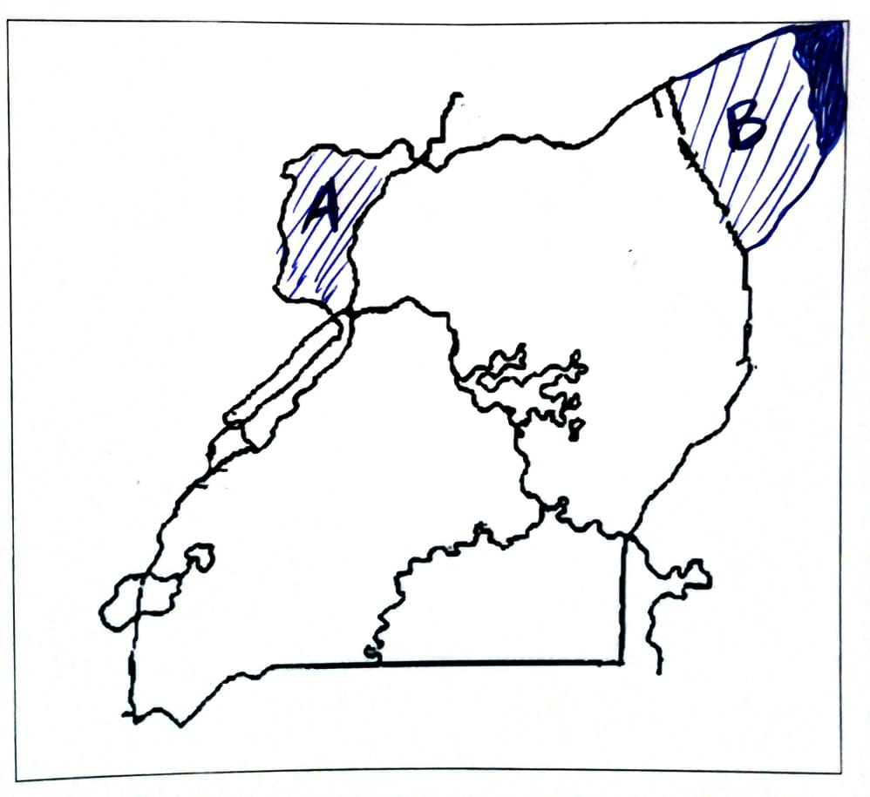

1. Name the colonial master who was incharge of the area marked A before the transfering of Uganda in 1914.

…………………………………………………………………………………………………………………………………………………………………………..

1. Why was area marked B transferred to Kenya in 1926.

……………………………………………………………………………………………………………………………………………………………………………

1. Give any two problems that were faced by people in Uganda when area B was transfered to Kenya.
2. ………………………………………………………………………………………………………………………………………………………………
3. ………………………………………………………………………………………………………………………………………………………………
4. a) Name any other tax that was introduced by the1900 Buganda agreement apart from hut tax.

…………………………………………………………………………………………………………………………………………………………………………….

b) How did hut tax negatively affect the people of Uganda.

……………………………………………………………………………………………………………………………………………………………………………..

1. Give any two reasons why colonialists introduced taxes in Uganda.
2. …………………………………………………………………………………………………………………………………………………………………
3. …………………………………………………………………………………………………………………………………………………………………
4. a) What is smuggling?

………………………………………………………………………………………………………………………………………………………………………………

b) Name the body that was set up by Uganda Revenue Authority to fight against smuggling.

……………………………………………………………………………………………………………………………………………………………………………

1. Give any two ways smuggling of goods negatively affect the economy of the country.
2. ……………………………………………………………………………………………………………………………………………………………
3. ………………………………………………………………………………………………………………………………………………………….
4. The diagram below represents balanced budget .Study it and answer questions that follow.

20,000,000/= 20,000,000/=

1. What is another name given to the above budget?

……………………………………………………………………………………………………………………………………………………………………………

1. Give any two advantages of making the above budget.
2. ………………………………………………………………………………………………………………………………………………………………
3. ……………………………………………………………………………………………………………………………………………………………
4. Write down any one disadvantages of making the above budget in the diagram

……………………………………………………………………………………………………………………………………………………………………………

1. a) Mention any one factor that lead people to having large families.

……………………………………………………………………………………………………………………………………………………………………………

b) Give any one advantage of havi ng a large family.

……………………………………………………………………………………………………………………………………………………………………………

C) Mention any two challenges faced by people living in a large family.

i. ……………………………………………………………………………………………………………………………………………………………………………

ii. …………………………………………………………………………………………………………………………………………………………………………

**For questions 51- 55, answer either Christianity or Islam but not both alternatives in a number. *No mark will be earned if you attempt both***

1. *Either:*

***Complete the sentences in B by matching with words in list A***

*List A List B*

*Adam The first person to be killed.*

*Abel The first person to sin*

*Eve The first person to kill.*

*Cain The first to hear God’s voice*

***OR***

***Complete the sentences in B by matching with words in list A***

*List A List B*

*Adam The first person to be killed.*

*Habeel The first person to sin*

*Hawa The first person to kill.*

*Quabeel The first to hear God’s voice*

1. *Either:*
2. *What is reconciliation?*

*……………………………………………………………………………………………………………………………………………………………………………*

1. *State any two benefits of reconciliation to Christians.*
2. *……………………………………………………………………………………………………………………………………………………………….*
3. *…………………………………………………………………………………………………………………………………………………………….*
4. *Mention any one way of reconciling with others.*

*……………………………………………………………………………………………………………………………………………………………………………*

*OR*

1. *What is reconciliation?*

*……………………………………………………………………………………………………………………………………………………………………………*

1. *State any two benefits of reconciliation to Muslims.*
2. *………………………………………………………………………………………………………………………………………………………………*
3. *……………………………………………………………………………………………………………………………………………………………….*
4. *Mention any one way of reconciling with others.*

*……………………………………………………………………………………………………………………………………………………………………………*

1. *Either:*
2. *What is selfishness?*

*……………………………………………………………………………………………………………………………………………………………………………*

1. *Give any two examples of selfish behavior among Christians.*
2. *………………………………………………………………………………………………………………………………………………………………*
3. *……………………………………………………………………………………………………………………………………………………………….*
4. *State any one effect of selfishness among Christians.*

*…………………………………………………………………………………………………………………………………………………………………………..*

*OR*

1. *What is selfishness?*

*…………………………………………………………………………………………………………………………………………………………………………..*

1. *Give any two examples of selfish behavior among Christians.*
2. *…………………………………………………………………………………………………………………………………………………………….*
3. *…………………………………………………………………………………………………………………………………………………………….*
4. *State any one effect of selfishness among Christians.*

*……………………………………………………………………………………………………………………………………………………………………………*

1. *Either:*
2. *What does the term Pentanteuch?*

*……………………………………………………………………………………………………………………………………………………………………………*

1. *From which part of the Bible is the Pentateuch found?*

*……………………………………………………………………………………………………………………………………………………………………………*

1. *Mention any two books of the Pentateuch.*
2. *……………………………………………………………………………………………………………………………………………………………….*
3. *………………………………………………………………………………………………………………………………………………………………*

*OR*

1. *What is a hadith?*

*……………………………………………………………………………………………………………………………………………………………………………*

1. *“ Bismillah Rahman Raheem.” What does the statement mean?*

*……………………………………………………………………………………………………………………………………………………………………………*

1. *Name the Prophet to whom the Holy Quran was revealed.*

*……………………………………………………………………………………………………………………………………………………………………………*

1. *How is a Qur’an a unique book?*

*……………………………………………………………………………………………………………………………………………………………………………*

1. *For both*
2. *What is a religion?*

*…………………………………………………………………………………………………………………………………………………………………………..*

1. *Mention any two examples of major world religions.*
2. *……………………………………………………………………………………………………………………………………………………………..*
3. *……………………………………………………………………………………………………………………………………………………………..*
4. *Which religion existed in Uganda before the coming of the foreigners?*

*……………………………………………………………………………………………………………………………………………………………………………*